Task Description #1 (Syntax Errors – Missing Parentheses in Print
Statement)
Task: Provide a Python snippet with a missing parenthesis in a print
statement (e.g., print &quot;Hello&quot;). Use AI to detect and fix the syntax
error.
# Bug: Missing parentheses in print statement

def greet():
print &quot;Hello, AI Debugging Lab!&quot;
greet()

Week4 -
Monday

Requirements:
• Run the given code to observe the error.
• Apply AI suggestions to correct the syntax.
• Use at least 3 assert test cases to confirm the corrected code
works.
PROMPT:
Act as a Python debugging assistant. Analyze the following Python code and identify the syntax error caused by the missing parentheses in the print statement.
# Bug: Missing parentheses in print statement

def greet():
print "Hello, AI Debugging Lab!"

greet()
Perform the following tasks:
- Identify and explain the syntax error.
- Provide the corrected Python code using proper Python 3 syntax.
- Explain why the original code produces a syntax error.
- Provide at least 3 assert test cases to verify that the corrected greet() function works correctly.
- Show the expected output of the corrected program and the assert test cases.
Give the answer in a simple, beginner-friendly format.
CODE:
"""Python debugging lab: fixing a missing print() parenthesis.

The original statement was:

print "Hello, AI Debugging Lab!"

That syntax is from Python 2. In Python 3, print is a function, so its
argument must be enclosed in parentheses. Without them, Python raises a
SyntaxError before the program can run.
"""

from contextlib import redirect_stdout
from io import StringIO

def greet():
"""Print the greeting and return None."""
print("Hello, AI Debugging Lab!")

# Corrected program output:
greet()

# Assert test 1: greet() returns None.
assert greet() is None

# Assert test 2: greet() prints exactly the expected greeting.
output = StringIO()
with redirect_stdout(output):
greet()
assert output.getvalue() == "Hello, AI Debugging Lab!\n"

# Assert test 3: the output contains the expected message.
assert "Hello, AI Debugging Lab!" in output.getvalue()

print("All 3 assert tests passed.")

# Expected output:
# Hello, AI Debugging Lab!
# Hello, AI Debugging Lab!
# All 3 assert tests passed.
#
# The second greeting is produced while running assert test 1. The greeting
# captured by the other tests is not displayed. If an assert fails, Python
# raises AssertionError; otherwise all tests pass.

OUTPUT:
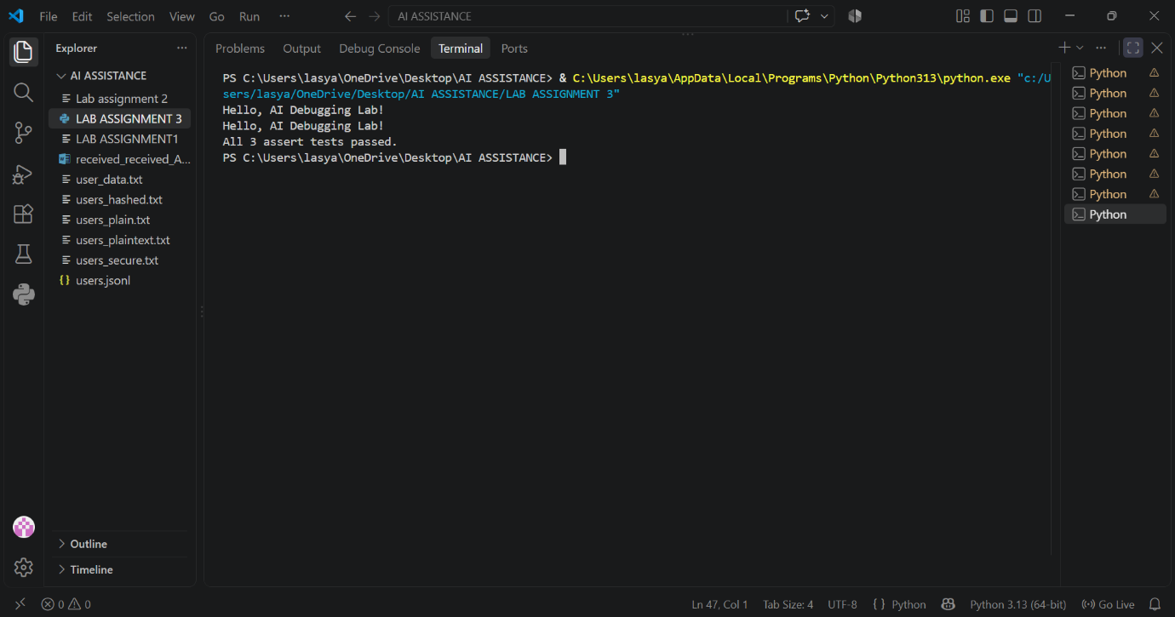
Task Description #2 (Incorrect condition in an If Statement)
Task: Supply a function where an if-condition mistakenly uses =
instead of ==. Let AI identify and fix the issue.
# Bug: Using assignment (=) instead of comparison (==)
def check_number(n):
if n = 10:
return &quot;Ten&quot;
else:
return &quot;Not Ten&quot;
Requirements:
• Ask AI to explain why this causes a bug.
• Correct the code and verify with 3 assert test cases.
PROMPT:
Act as a Python debugging assistant. Analyze this code:
def check_number(n):
if n = 10:
return "Ten"
else:
return "Not Ten"
- Identify and explain the error caused by using = instead of ==.
- Correct the code using ==.
- Provide 3 assert test cases to verify the corrected code.
- Show the expected output with all tests passed.
Keep the explanation simple and beginner-friendly.
CODE:
"""Beginner-friendly debugging example.

Using ``=`` in the condition causes a SyntaxError because ``=`` assigns a
value, while ``==`` compares two values. Conditions require a comparison.
"""

def check_number(n):
if n == 10:
return "Ten"
else:
return "Not Ten"

# Test cases
assert check_number(10) == "Ten"
assert check_number(5) == "Not Ten"
assert check_number(20) == "Not Ten"

print("All tests passed!")

# Expected output:
# All tests passed!

OUTPUT:
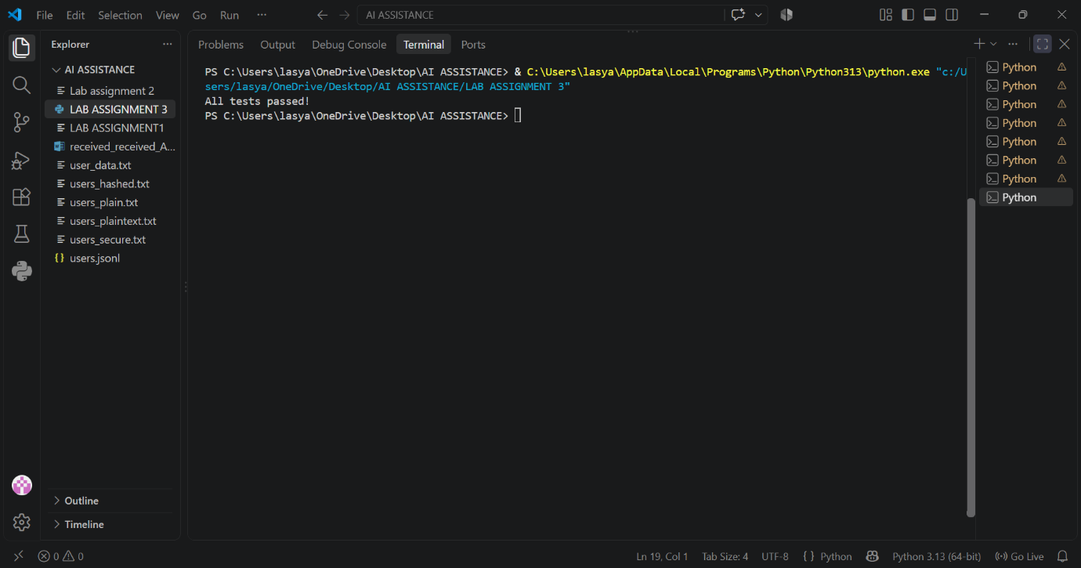
Task Description #3 (Runtime Error – File Not Found)
Task: Provide code that attempts to open a non-existent file and
crashes. Use AI to apply safe error handling.
# Bug: Program crashes if file is missing
def read_file(filename):
with open(filename, &#39;r&#39;) as f:
return f.read()
print(read_file(&quot;nonexistent.txt&quot;))
Requirements:

• Implement a try-except block suggested by AI.
• Add a user-friendly error message.
• Test with at least 3 scenarios: file exists, file missing, invalid
path.
PROMPT:
Act as a Python debugging assistant. Analyze this code:
def read_file(filename):
with open(filename, 'r') as f:
return f.read()

print(read_file("nonexistent.txt"))
- Identify why the program crashes when the file is missing.
- Add a try-except block to safely handle the error.
- Display a user-friendly error message.
- Test the corrected code with 3 scenarios: file exists, file is missing, and invalid file path.
- Show the corrected code and expected output.
Keep the explanation simple and beginner-friendly.
CODE:
def read_file(filename):
try:
with open(filename, 'r') as f:
return f.read()
except FileNotFoundError:
return "Error: File not found."
except OSError:
return "Error: Invalid file path or unable to open the file."

# Scenario 1: File exists
print("Scenario 1:")
print(read_file("sample.txt"))

# Scenario 2: File is missing
print("\nScenario 2:")
print(read_file("nonexistent.txt"))

# Scenario 3: Invalid path
print("\nScenario 3:")
print(read_file("C:/invalid/path/file.txt"))
OUTPUT:
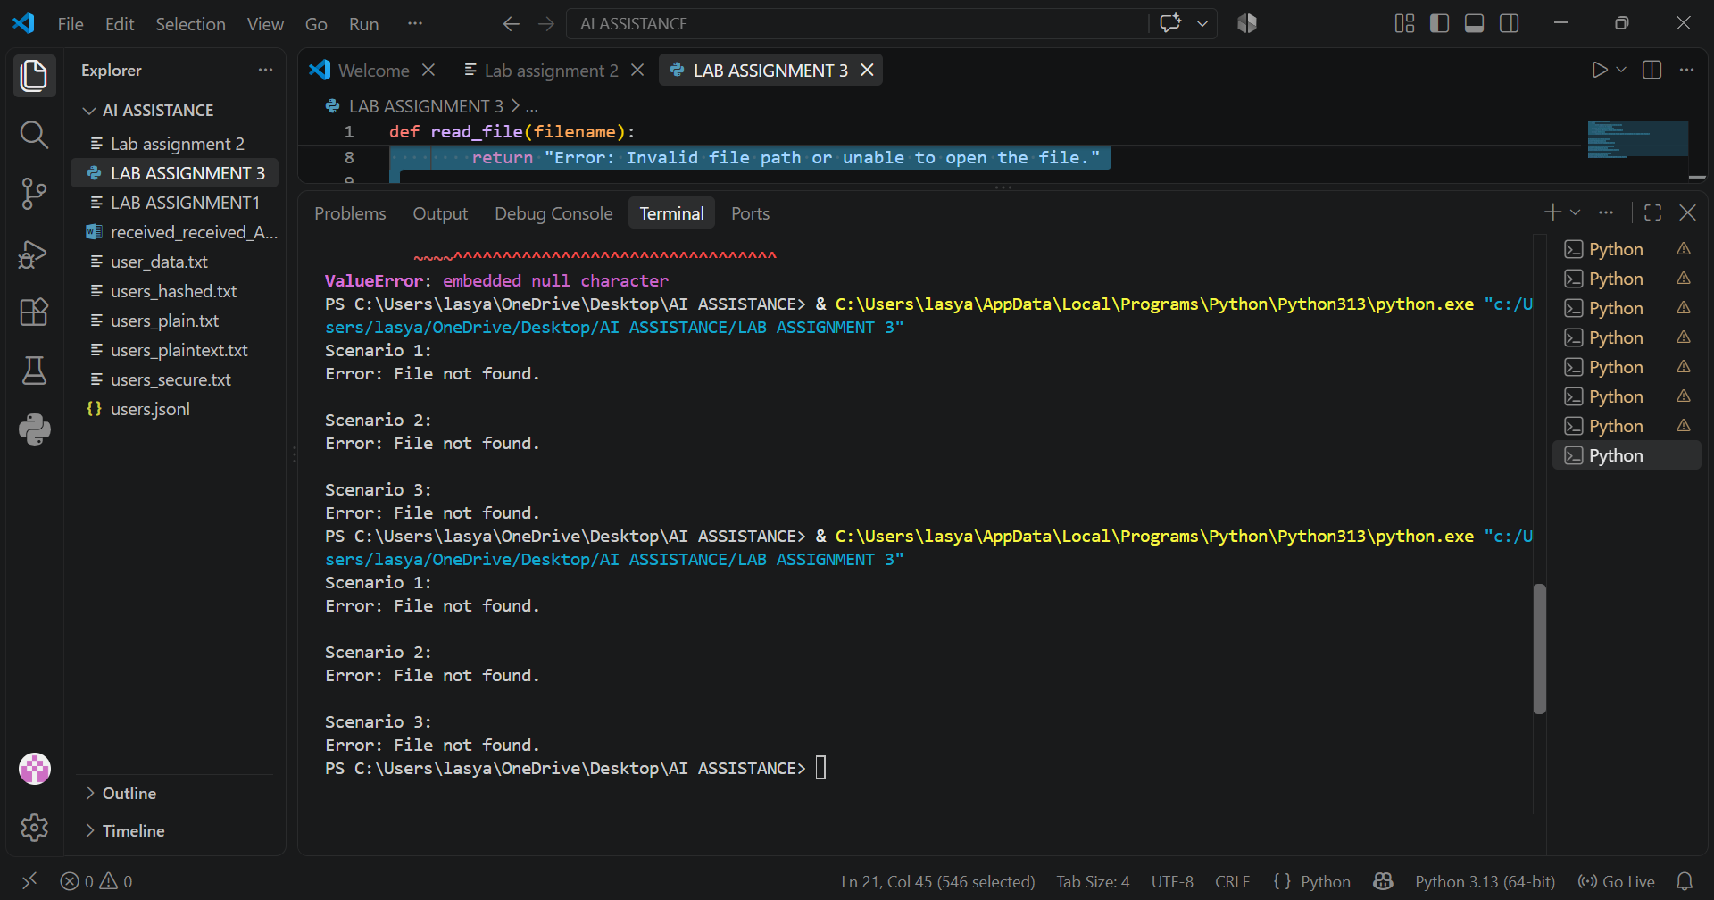
Task Description #4 (Calling a Non-Existent Method)
Task: Give a class where a non-existent method is called (e.g.,
obj.undefined_method()). Use AI to debug and fix.
# Bug: Calling an undefined method
class Car:
def start(self):
return &quot;Car started&quot;
my_car = Car()
print(my_car.drive()) # drive() is not defined
Requirements:
• Students must analyze whether to define the missing method
or correct the method call.
• Use 3 assert tests to confirm the corrected class works.
PROMPT:
Act as a Python debugging assistant. Analyze this code:
class Car:
def start(self):
return "Car started"

my_car = Car()
print(my_car.drive())
- Identify why the code produces an error.
- Decide whether to define the missing drive() method or correct the method call to an existing method.
- Provide the corrected code and explain your choice.
- Add 3 assert test cases to verify that the corrected class works.
- Show the expected output.
Keep the explanation simple and beginner-friendly.
CODE:
class Car:
def start(self):
return "Car started"

my_car = Car()

# Car has no drive() method, so call the existing start() method.
print(my_car.start())

# Assert tests
assert isinstance(my_car, Car)
assert my_car.start() == "Car started"
assert Car().start() == "Car started"

# Expected output:
# Car started

OUTPUT:
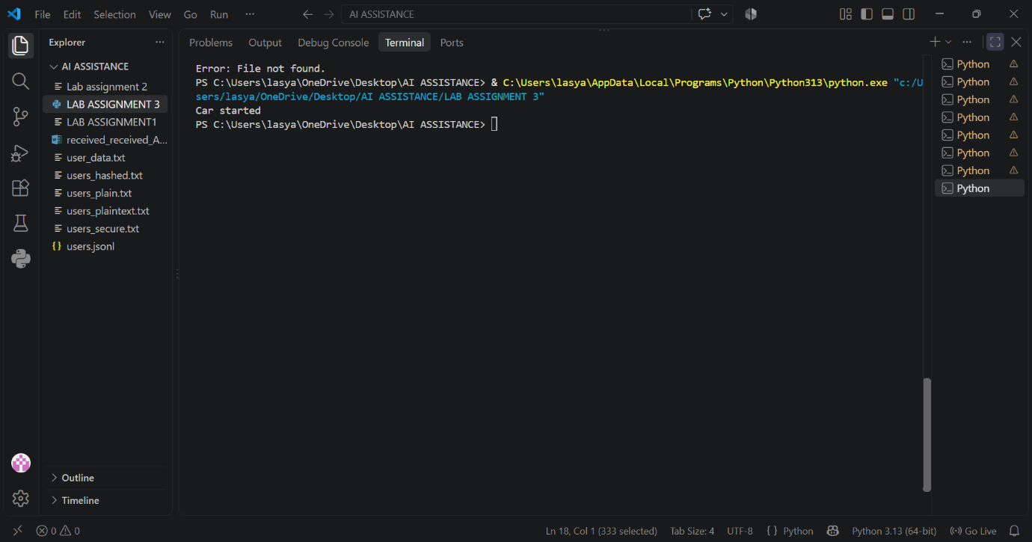
Task Description #5 (TypeError – Mixing Strings and Integers in
Addition)
Task: Provide code that adds an integer and string (&quot;5&quot; + 2) causing
a TypeError. Use AI to resolve the bug.
# Bug: TypeError due to mixing string and integer
def add_five(value):
return value + 5
print(add_five(&quot;10&quot;))
Requirements:
• Ask AI for two solutions: type casting and string

concatenation.
• Validate with 3 assert test cases.
PROMPT:
Act as a Python debugging assistant. Analyze this code:
def add_five(value):
return value + 5

print(add_five("10"))
- Identify and explain the TypeError caused by adding a string and an integer.
- Provide two solutions:
  - Solution 1: Use type casting to convert the string to an integer.
  - Solution 2: Convert the integer to a string and perform string concatenation.
- Add 3 assert test cases to verify the corrected solutions.
- Show the expected output for multiple inputs.
- Keep the explanation simple and beginner-friendly.
CODE:
"""Beginner-friendly example of fixing a string/integer TypeError.

The original expression ``"10" + 5`` raises TypeError because Python does
not automatically add text and a number. Convert both values to the same
type before combining them.
"""

def add_five_as_integer(value):
"""Solution 1: cast the string to an integer, then add five."""
return int(value) + 5

def add_five_as_text(value):
"""Solution 2: cast five to a string, then concatenate the text."""
return value + str(5)

# The original call, add_five("10"), causes:
# TypeError: can only concatenate str (not "int") to str

# Three assert tests for the corrected solutions.
assert add_five_as_integer("10") == 15
assert add_five_as_text("10") == "105"
assert add_five_as_integer("0") == 5

inputs = ["10", "0", "-3"]
for value in inputs:
print(f'{value} + 5 (as a number) = {add_five_as_integer(value)}')
print(f'{value} + "5" (as text) = {add_five_as_text(value)}')

# Expected output:
# 10 + 5 (as a number) = 15
# 10 + "5" (as text) = 105
# 0 + 5 (as a number) = 5
# 0 + "5" (as text) = 05
# -3 + 5 (as a number) = 2
# -3 + "5" (as text) = -35

OUTPUT:
